Software Project Report

Phaser Game

N00172752

INDEX

1. Introduction.
2. Planning/Research.
3. Game/Code.
4. Results/Conclusion.
5. Difficulties.
6. Bibliography.

**01**

Introduction.

For our first software project continuous assessment this year, we were told to design a game using a JavaScript based web game. Phaser is a desktop and mobile HTML5 framework. It’s a free open source framework for canvas and webGL powered browser games. The phaser library has a wide selection of different game types and allows full customization and freedom to design the game to your liking.

**02**

Planning / research.

Knowing that we were going to be primarily using phaser for this assessment, there was a large library of game and game types that you could base an idea off. We were informed at the start that we would be working mainly with phaser 3. Phaser 3 is still in its beta stages when it comes to its physics and range of variations of commands. I decided to go with the basic concept of *pong* as my game style of choice.

This allowed me full creativity with how the game would play and more importantly how the game looked. This creative edge allowed me to explore different concepts. I started with the idea of bumper cars and what looked like a “football pitch” as the playing field. That didn’t sit well with me when I roughly sketched it on paper, so I went back to the drawing board on “what did I like” and “what games did I play as a kid”. Then it hit me, Pokémon! I played Pokémon as a kid (probably far to much) and decided that yes, I can make the playing field look like a gym battle, except its pong.

Breaking it down now, I had to figure what the ball and paddles would be to keep to the Pokémon theme of this game. I played around with the idea of making actual characters as the paddles but quickly scrapped the idea due to the lack of said creatures involved. I saw a great sketch of Pikachu’s tail (Pikachu is probably the most well-known one of the Pokémon creatures) and decided to go to photoshop and recreate the rough idea, until I had perfected the concept. My paddles were born. The ball was the last of the things to design in photoshop but it was really a no brainer . A poke ball that’s normally used to capture the creatures was the best choice.

**The rough design sketches:**

paddle design example will be based on pikachus tail.

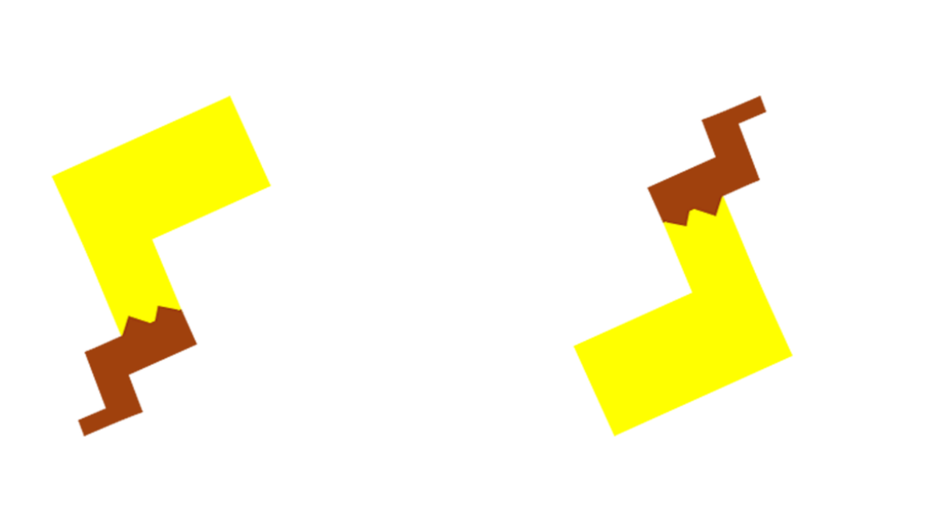

The ball concept is based on a basic pokeball.



03

Game/Code.

After finishing the rough sketches on photoshop and laying out exactly what was going to be needed, I then found examples on phasers website of small packets of code that I could use as a basis for my game. There was multiple different classes I needed to use to make the game run as a whole. Some of these classes include a create, update, launch_ball, and paddle.

E.G of this code is as follows:

function update () {

// s.tilePosition.x += (game.input.speed.x / 2);

paddle.x = game.input.x;

if (paddle.x < 24)

{

paddle.x = 24;

}

else if (paddle.x > game.width - 24)

{

paddle.x = game.width - 24;

}

if (ballOnPaddle)

{

ball.body.x = paddle.x;

}

else

{

game.physics.arcade.collide(ball, paddle, ballHitPaddle, null, this);

game.physics.arcade.collide(ball, bricks, ballHitBrick, null, this);

}

}

This is just a small sample of pseudocode that was manipulated to use within my game. Most of the bare bones of this code is usable, but this exact example was from a different game entirely.

**04**

Results/Conclusion

After the majority of the code has been typed out and the assets have been created in photoshop, the following screenshots are the results of the game I had built. 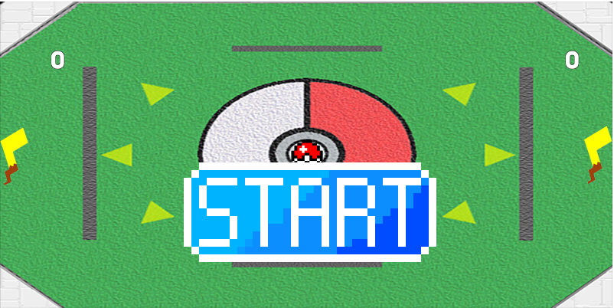

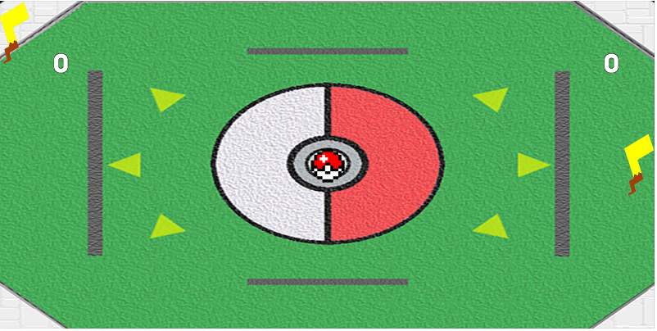

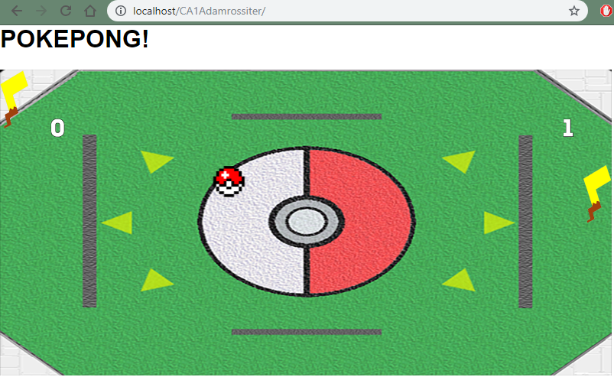

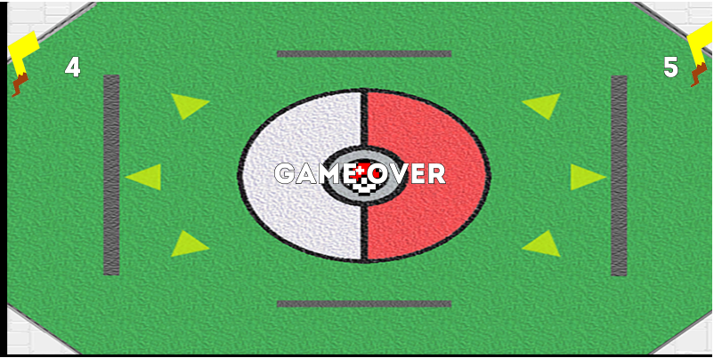

05

Difficulties

The major issue I had with the entire project is the limitations phaser 3 had on the ideas of what games could have been created. In using phaser 2, there was far more of a selection on the range of games to code and add your own touch on. I ended up going with a phaser 2 game and understand completely that I will be marked harshly when it comes to my choice.

Other difficulties I came across was trying to build a main menu. The code required to build it was a little to much for me to wrap my head around and I attempted it multiple different times. Overall though I found this assessment a great exercise, I learned a fair amount of how JavaScript works, and how many errors you’re bound to run into while running the game.

**06**

Bibliography

https://phaser.io/

<https://codereview.stackexchange.com/questions/172604/classing-pong-game>